write final paper title here
A template and guidelines for authors- any subtitle – 20 words maximum both main and subtitles
Author fAMILY NAME. A1, Author FAMILY NAME. B2 and AUTHOR FAMILY NAME C3
^{1, 2}First institution, Then city, Then country
email of first author@first institute
³Second institution, Second city, Second country
email of author@second institute

(Write only the ID number when submitting the final paper for review
Write the names of authors, affiliations and contact e mails when submitting the print ready final paper after reviewer comments)

Abstract. The abstract should write like this with one paragraph. It should explain the research context, issues investigated, the methodology used, and findings discussed. The abstract should be without any citation, references and unexplained abbreviations and has not more than 200 words. Cambria 08pt, leading 10 pt. Space before: 30 pt.
Keywords. Five key words- maximum

1. Introduction – this is an essential section of the paper
This paper should commence with an introduction to the work. In addition, the paper should include sections for research methodology, a conclusion, an acknowledgement and list of references. This document contains paragraph and character styles that will cover most formatting requirements of the final paper.

When you prepare your paper for a review, do not include all identifying information (e.g., authors’ names, affiliations, or references to these) on all submissions. Identify your paper with the ID number. But include this information later when you submit print ready final paper after your paper has been accepted for inclusion in the conference.

Submit your full-paper for the next review as a MS Word-file, which includes images with a high resolution using this word template. Identify your file name as the ID number allocated for your paper when uploading or submitting. Submit your final print ready paper, with the changes required by the reviewers and the Paper Selection Committee as a Word document using this template inserted with images. These will make it easier to prepare the paper for publication. You will receive specifications for these later.
2. Heading Level 1- Format of a typical page and final proceeding book
Heading Level 1 in main text will be in bold 11pt. The page of the final proceeding book measures 170 mm wide by 240 mm high. The text including figures fit into a rectangle of 120 mm by 197 mm. The inside and outside margins of final book are both 25 mm; the top and bottom margins are both 21.5 mm. However, this document is set for A4 paper of which margins are respectively 50 mm and 45 mm.

Left indent when starting a paragraph except the first paragraph of all sections, sub sections etc. There are no footers.
3. Heading Level 1- General paper formatting issues
It is recommended to have at least one paragraph of text underneath each heading. The maximum number of pages should be 12 including images and references – when formatted with this template. Final publication may not look exactly like the document you submit. Both the text and the formatting may not be edited for the final proceedings, therefore, please follow the template formatting. Submit your print ready final paper in word format. Cambria 11 pt, bold, space before: 14 pt. Space after: 10 pt.
3.1. Sub heading – level 2
This is a second level heading style. Space before: 14 pt. Space after: 10 pt. Font: bold CAPITAL. Use UK spelling. Use a spelling checker and a grammar checker. Then check again manually to catch problems like homonyms. Have a third person check your manuscript. Format your paper simply to look like this document. Limit the number of pages to 12.

3.1.2 Sub heading – level 3
Use this format (Italic) for any sub headings of level 3. The font size will remains as of the other text. Space before: 14 pt. Space after: 10 pt.
4. Font matter and headers
There has to be at least one paragraph after a heading or sub heading
4.1. main Title of the paper
Use following for the title of the paper, Cambria bold all caps, 11 pt, leading 13 pt. Align text left: 20 mm.

Sub title under the main title
Cambria all caps, 11 pt, leading 13 pt. Align text left indent: 20 mm. titles, sub titles should use sentence capitalisation, not headline capitalisation.

Sentence capitalisation: National society for monuments and historic places
Headline capitalisation: National Society for Monuments and Historic Places
Cambria italic, 11 pt, leading 13 pt. Left indent: 20 mm. Space before: 15 pt.
4.2. Authors’ names
Authors’ given names should come first and then their family names. Include author information only when your paper has been accepted for inclusion in the conference proceedings. Cambria font, 10 pt, leading 12 pt. Left indent 20 mm. Space before: 24 pt

4.3. Affiliation
Affiliation is the university, school or institute and not the department. Affiliation should consist of the name of the institution, the city, the country, and the e-mail address. Include affiliation information only once your paper has been accepted for inclusion in the conference proceedings.
4.4. Abstract
The abstract shall be in one paragraph, should not contain any citations/references or unexplained abbreviations. Abstract in the final paper should include some of the findings of the research.
4.5. Keywords
You may list up to five keywords. The first is capitalised. The keywords are separated by semicolons and terminated with a period. The in-line title (“Keywords.”) Cambria 8 pt, leading 11 pt. 20 mm. leading 10 pt. Space before: 30 pt.

4.6. Headers
4.6.1. Citation header
The citation header is the same for all papers, except for the page numbers, which will be inserted later by the Conference Secretariat. Do not alter it and keep it as shown.

Cambria, 8pt, leading 12 pt. Justified. Space after: 64 pt.
4.6.2. Even-page headers
The headers on even pages contain the page number and the authors’ names. The page numbers are generated automatically. The authors’ names should not exceed one line; use initials for first names and “et al” if necessary: e.g A.R. AUTHOR NAME, B.R. AUTHOR AND C.R. AUTHOR.

Include author information only when your paper has been accepted for inclusion in the conference. Align text left Space after: 24 pt.
4.6.3. Odd-page headers
The headers on odd pages (except the first) contain the title and the page number. The title should not exceed one line; abbreviate it if necessary. Align text right

Space after: 24 pt.
5. Text
5.1 Text first
The first paragraph of text following a heading is not indented. It is the root style of all other paragraph styles in this document.

Font: Geogia Size: 10 pt. Leading: exactly 12 pt. Language: English (UK). Widow/orphan control.
5.2. Text
All text throughout the paper except the first paragraphs of each section or sub section has an indent of 5 mm.
5.3. Bullet lists
Bullet texts can be a part of the paper. They can either be separated from the text proceeding or following. An example is shown below.
- bullet text style. Size: 10 pt. Leading 12 pt. Left indent: 10 mm. First line indent: –5 mm. Space before: 6 pt.
5.4. Figures
Figures should be described appropriately in the text after referring it in the relevant text (Figure 1). The Figure should have one line (13 pt) of space before the figure and after the caption (except at the end of a section). Do not leave a space between the image and the caption. The caption of the figure should be just below the figure.
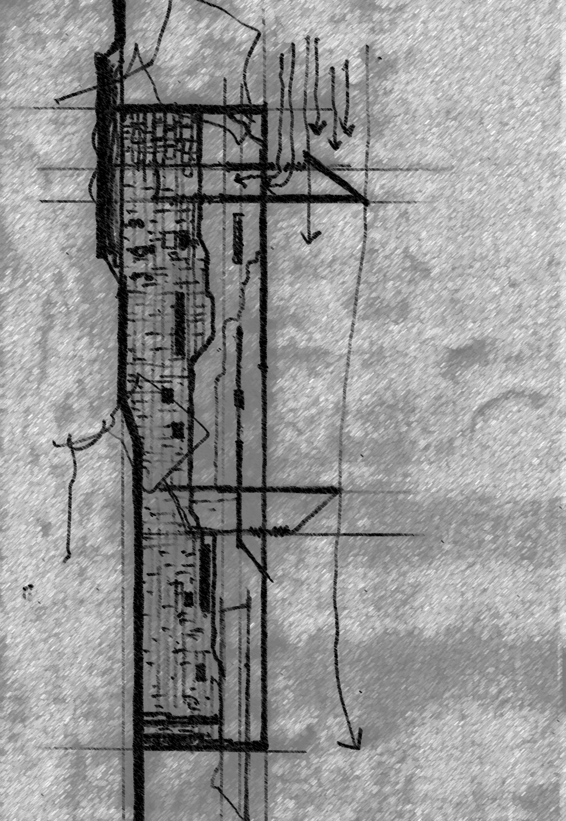
Figure 1, Caption should be just below the figure (Source: Rajapaksha U)

Full paper review manuscripts should contain Figures. In addition, they should be submitted in high resolution MS Word format with final paper.
5.5. Tables
Tables should be placed into the text just after referring to it in the text. They should be numbered as (Table 1) etc. They should have one line (13 pt) of space before the caption and after the table. The caption for a table should be written just above the table. Cambria font with a size of 8 points and minimum leading of 9 points.

5.6. Equations
Equations should be numbered in parentheses at the right margin.
H2 = x2y2 + Rx2 + 3Dxy (1)
6. Citations and References
Harvard author-date style should be used for this purpose. Citations can be as follows;
- As Perera (1986) has illustrated …
- Bandara et al (2000) presented in …
6.1. Endnotes
The organizers recommend that authors do not to use any Endnotes.
6.2. Acknowledgements
Size: 9 pt. Leading: 10 pt.
6.3. References
Size: 9 pt. Leading: 10 pt. Left indent: 5 pt. First line indent: –5 mm.
References (sample)
Hyde, R. 2000 Climate responsive design: a study of buildings in moderate and hot humid climates, London: E and FN Spon

Olgyay, V., Olgyay, A. 1963 Design with climate: bio-climatic approach to architectural regionalism, New Jersey: Princeton University Press

Perera, D.C. and Bandara, H.M: 1988, Title of the paper in Italic……… in Name/s of Editors (ed), title of the proceedings, Title of the conference, Association of the conference, City

Perera, D.C and Nammuni, H.Y: 2013, Title of the paper In Italic, Journal name, Publisher, City, page numbers of the paper

Smythe, J. S. (ed.): 1990, Title of the book, Publisher of the book, City

Web, B.: 2012, “Title of the web article”. Available from: Open Source Repository - address of the web site (accessed 1October 2014).

